Documentation on Different Types of Networks
1. Introduction
A network is a collection of computers, servers, mainframes, network devices, or other devices connected to share data, resources, and communication. Networks allow users to exchange information and share resources efficiently. Networks can be classified based on their size, topology, and geographical spread.

2. Types of Networks
2.1. Local Area Network (LAN)
- Definition: A LAN connects computers and devices within a small geographic area, like a home, office, or building.
- Features:
  - High data transfer rates (typically 100 Mbps to 10 Gbps)
  - Limited geographical coverage
  - Low cost and easy to maintain
- Uses: Office networks, schools, and home networks
Diagram of LAN:
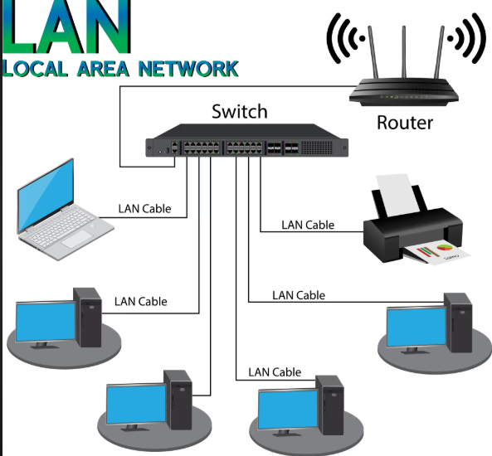

2.2. Metropolitan Area Network (MAN)
- Definition: A MAN connects multiple LANs within a city or large campus. It is larger than a LAN but smaller than a WAN.
- Features:
  - Covers a city or town
  - Medium-speed connections
  - Can be managed by a single organization or multiple ISPs
- Uses: City-wide internet services, universities, and large corporate campuses
Diagram of MAN:
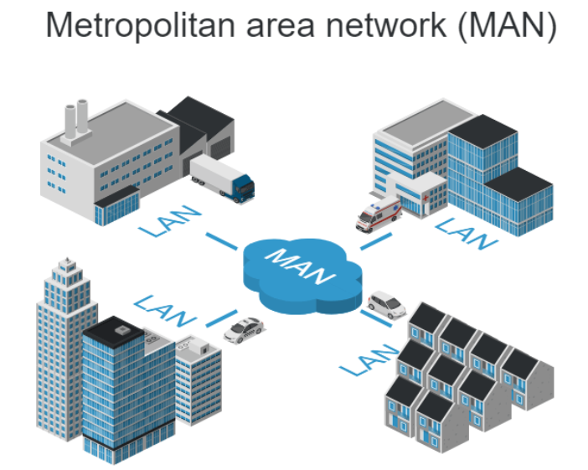

2.3. Wide Area Network (WAN)
- Definition: WAN spans large geographical areas such as countries or continents. The Internet is the largest example of a WAN.
- Features:
  - Low to medium data transfer speed
  - High cost due to long-distance connections
  - Can connect LANs and MANs
- Uses: Multinational corporations, banking networks, global communication
Diagram of WAN:
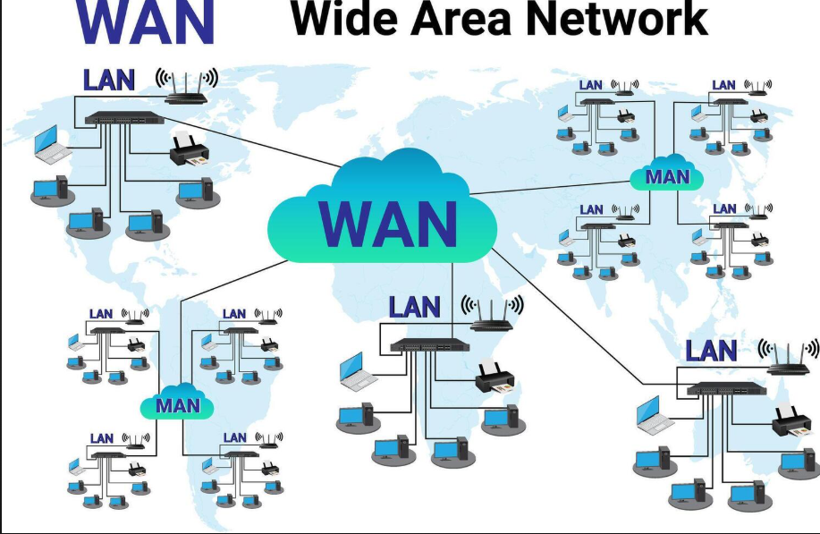

2.4. Personal Area Network (PAN)
- Definition: PAN is a small network used for communication among devices close to one person.
- Features:
  - Very limited range (typically <10 meters)
  - Connects devices like smartphones, laptops, and printers
- Uses: Bluetooth devices, USB connections, wearable technology
Diagram of PAN:

2.5. Wireless Local Area Network (WLAN)
- Definition: A LAN that uses wireless communication technology (Wi-Fi) instead of wired connections.
- Features:
  - High mobility and flexibility
  - Easy to expand and install
  - Subject to interference and security risks
- Uses: Wi-Fi networks in homes, cafes, and offices
Diagram of WLAN:
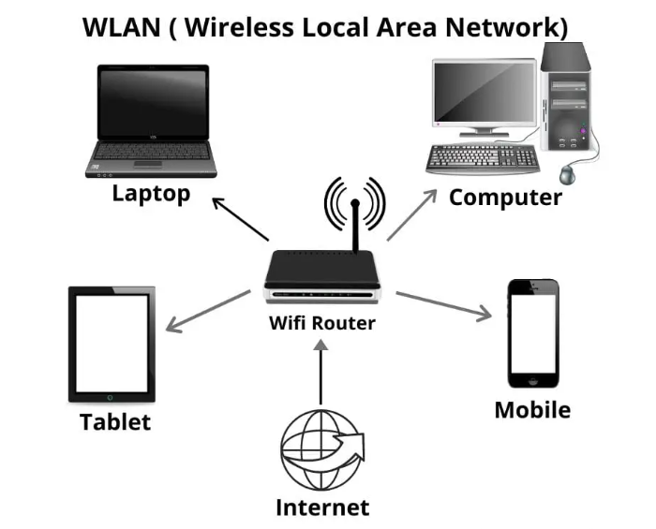
2.6. Storage Area Network (SAN)
- Definition: SAN is a specialized network that provides access to consolidated, block-level data storage.
- Features:
  - High-speed network
  - Used for data storage and backup
  - Enhances storage efficiency and performance
- Uses: Data centers, enterprise storage solutions
Diagram of SAN:
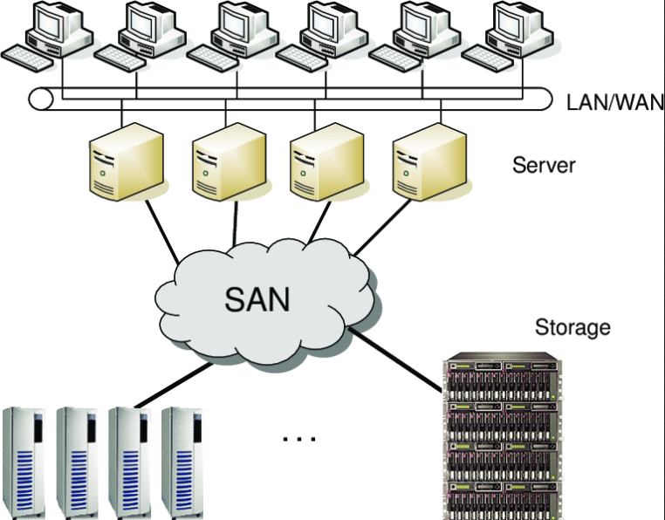
3. Conclusion
Networks play a vital role in modern communication and business. Choosing the right type of network depends on coverage area, speed, cost, and purpose. LANs and WLANs are ideal for local communication, MANs serve cities, and WANs connect global networks. PANs and SANs serve specialized purposes for personal devices and storage solutions, respectively.

